SACA
Smart Adaptive Clinical Assistant
Handover Pack
Everything a new owner needs to deploy, use, test and move the project forward

Item | Detail
Project | P51-SACA: offline English and Swahili symptom triage for remote clinics (Mbinga District, Tanzania)
Version | 1.0, 21 October 2026
Prepared by | Team P51, Swinburne University of Technology, ICT30018 ICT Project B
Client / supervisor | Siva (client), Harsharan Kaur (supervisor)
Status of the software | Working prototype. Not a medical device. Not clinically validated.
Code state described | The working copy used to produce this pack (the repository including the 14 to 17 October changes: dataset v2, input guard, English and Swahili reader). [Confirm everything is committed and pushed before handing over]

Read this first
SACA is a student prototype. Its urgency levels come from rules the team wrote and have not been reviewed by a clinician. Do not use it to make decisions about real patients until the clinical review in section 10 has been done.

Contents
1 At a glance (the pitch)
2 Project context, team and decisions
3 How the system works
4 Deployment guide
5 User manual
6 Data scenario
7 Test plan
8 Test report
9 Known issues and risks
10 Roadmap: how to move forward
11 Handover checklist
Appendix A Test case scenarios (116 cases)
Appendix B Glossary and references
Sections 1 to 4 are for anyone deciding whether and how to take the project on. Sections 5 to 8 are the working documents (manual, data, test plan, test report). Sections 9 to 11 say what is broken or missing and what to do next.

1 At a glance

What SACA is
SACA (Smart Adaptive Clinical Assistant) reads symptoms typed in English or Swahili and returns one of four urgency levels, LOW, MEDIUM, HIGH or CRITICAL, with a reason. It is built for places like Mbinga District, Tanzania, where a clinic can be hours away and internet is weak. The classifier is a small logistic regression model that trains from a CSV file in about a quarter of a second when the app starts, so the core triage works with no internet and no cloud service.

Why it is worth continuing
- Offline by design. The triage path needs no network. Only the optional LLM rewording of AMMU chat replies uses the internet, and it falls back to fixed text when it is unavailable.
- Two languages. Swahili phrases and about 250 English phrases are converted to symptom codes before the model sees them.
- Safety is built around the model, not left to it. Danger signs (89 rules) can only raise the level. Vague symptom sets cannot exceed MEDIUM. Input the system does not understand is reported as NOT ASSESSED instead of a reassuring LOW.
- Reproducible and tested. The dataset is rebuilt byte-for-byte by one script, and 138 automated tests plus 116 scenario cases pass today (section 8).
- Honest about its limits. Every known gap is listed with a suggested fix in section 9, so a new owner starts from facts.

Where it stands
Area | State | Evidence
Triage engine (reader, model, ceiling, floor, guard) | Working | 138 pytest tests; 116 scenario cases (Appendix A)
English and Swahili input | Working for a fixed phrase list | English 14/14 and Swahili 19/19 sample phrases; coverage is not complete
Web dashboard and body map (Flask) | Working | Screens in section 5; runs without any API key
AMMU chat and API (FastAPI) | Working, with a startup quirk | Needs the GROQ_API_KEY variable set to start (section 4.3)
Session storage and sync | Partly built | SQLite storage and sync endpoints exist; nothing uploads to a server
LLM symptom extractor | Not built | Placeholder that raises NotImplementedError
Installable Windows app | Not built | No PyInstaller spec or desktop shell in the repository
Clinical validation | Not done | All 89 rules and 41 disease tiers are DRAFT; review pack ready, no ratings yet

What the accuracy figure does and does not mean
The app scores 90.9% on its held-out test file. That file is labelled by the team's own rules, so the figure shows the model reproduces those rules. It is not a measure of clinical accuracy. The first non-circular number will come from the clinician review (section 10).

If you take this on: the first five moves
1. Send the clinician review pack (dataset_v2/review/clinician_review_sheet.xlsx) to a clinician or Tanzanian health worker and score the result with score_review.py.
2. Check every DRAFT rule and tier against its source and record the source in red_flags.csv and disease_urgency.csv.
3. Fix the quick wins in section 9 (startup key, debug flag, stale README, misleading banner).
4. Decide the deployment model (section 4.5) and build it: a Windows executable is the stated target and has not been started.
5. Have Swahili-speaking users test the wording and add negation and age handling (section 10).

2 Project context, team and decisions

Context
SACA is the P51 capstone in ICT30018 ICT Project B at Swinburne University of Technology. The client is Siva and the supervisor is Harsharan Kaur. The target setting is rural clinics and communities in Mbinga District, Tanzania, where most people speak Swahili, clinics can be far away, and connectivity is unreliable.

Team and ownership
Roles below are as assigned on 24 September 2026 and changed during the project. [Confirm current owners before relying on this table]
Person | Main areas
Minh-Hieu Ong | Team lead and scrum master. Dataset v2, classifier changes (reader, guard, ceiling, floor), tests, reports, repository fixes.
Ryan Cheng | Logistic regression classifier and pipeline integration (with Shayan); model serialisation.
Md Shayan Ibteshum | AMMU chat, Groq LLM wiring and safety check, planned voice feature.
Abdullah Azzam | Packaging into an executable and offline fallback. Original SVM prototype (retired).
Hitesh Kumar | Testing and CI, dataset documentation, bilingual dataset work (superseded by dataset v2).

A sixth member, Mumba, withdrew from the unit on 11 September 2026; the Random Forest track was cancelled.

Decision log
These decisions explain why the code looks the way it does. Reversing one needs a deliberate team decision, not a quiet code change: two of them were silently reverted by merges and web uploads in September.
Date | Decision | Reason
9 Sep | Quote 69.6% (not 94.0% / 96.75%) for the old models | The earlier test file shared every symptom text with the training file; a direct set check found the leak.
11 Sep | Logistic regression is the only classifier; SVM dropped, Random Forest cancelled, rule_based retired from the app | SVM and LR predicted identically on all 888 test rows; LR gives a native probability for confidence.
11 Sep | Target a Windows desktop app | Reuses the HTML interfaces without shipping a full browser runtime. The desktop shell was never built.
24 Sep | LLM only rewords the reply after the level is known (never extracts symptoms or sets the level) | Keeps the level deterministic and safe if the LLM is wrong or offline.
24 Sep | logistic_regression.app.py (Flask) is the working front end going forward | New dashboard from the team.
14 to 17 Oct | Dataset v2: labels from red-flag rules plus disease urgency; train on symptom codes only; reader, ceiling, floor and guard added | Old labels were a weighted symptom count (coma alone summed to LOW) and 76% of training rows were three Swahili sentence templates.

Timeline
Period | What happened
Weeks 1 to 4 (3 to 30 Aug) | The original repository and Jira project were lost over the semester break and had to be re-established; rule-based and SVM classifiers verified; client meeting scheduling escalated to the unit coordinator.
Weeks 5 to 8 (31 Aug to 27 Sep) | Leakage found and corrected; LR-only decision; LR made live; two regressions found and reversed; Sprint 5 tasks reassigned.
After the Sprint 5 report (from 5 Oct) | Input guard; dataset v2; English and Swahili reader; red-flag floor; clinician review pack; poster feedback; one-slide elevator pitch.

3 How the system works

Architecture
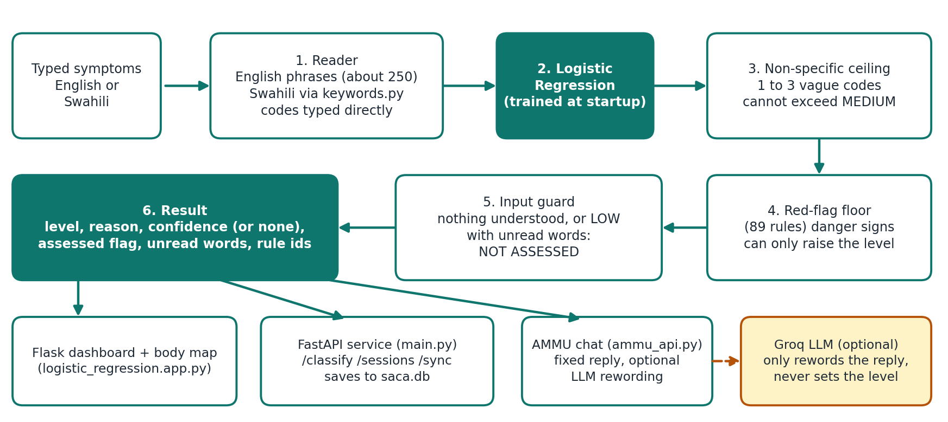
Figure 1. From typed symptoms to a result, and the three ways it is served.

How one request is decided
1. Read. classifier/symptom_codes.py turns the text into symptom codes. English phrases are matched first (whole words, longest phrase first), then Swahili phrases through keywords.py and dataset_v2/code_crosswalk.csv. A matched phrase is consumed, so "kukohoa damu" gives only blood_in_sputum. Symptom codes typed directly (for example chest_pain) pass through.
2. Predict. The logistic regression model gives a level and a probability.
3. Ceiling. If the input is only 1 to 3 vague symptoms (headache, nausea, vomiting, fatigue, malaise, loss of appetite, muscle, joint or back pain, dizziness, cough, abdominal pain), the level cannot exceed MEDIUM.
4. Floor. If every code of a red-flag rule is present, the level cannot be lower than that rule's tier. The floor only raises. When the ceiling or floor changes the result, confidence is null and the reason says why.
5. Guard. If nothing was recognised, or some words were not understood and the final level is LOW, the result is NOT ASSESSED. It is returned as severity HIGH with assessed=false, because the shared result builder only accepts the four real levels, and HIGH is the safe direction.
6. Return. The codes recognised are returned in input order, with the reason, the list of unread words and the ids of the red-flag rules that matched.

The result object
Field | Meaning
severity | LOW, MEDIUM, HIGH or CRITICAL. NOT ASSESSED is sent as HIGH with assessed false.
severity_sw | The Swahili label for the level (for example HATARI for CRITICAL).
symptoms | Symptom codes recognised, in input order.
reason | Plain-language reason. Bilingual (Swahili / English) when the guard or floor acted.
confidence | Model probability from 0 to 1, or null when the ceiling, floor or guard decided. It is agreement with our rule-based labels, not clinical certainty.
assessed | False when the input could not be rated. Callers must check this.
unrecognised | Words the system did not understand.
red_flag_rules | Ids of red-flag rules whose codes were all present (for example RF03).
classifier, disclaimer | Name of the classifier and the standard Swahili disclaimer line.

Key files
File or folder | Purpose
logistic_regression.app.py | Flask dashboard (/) and body map (/body-map). Uses SACAPipeline.
main.py | FastAPI service: /classify, /sessions, /sync/pending, /sync/confirm, /keywords, /ammu, /ammu/respond. Saves each session to saca.db.
ammu_api.py, ammu.html, ammu_safety.py | AMMU chat: builds a fixed reply for the level, optionally rewords it with Groq, and accepts the LLM text only if check_reply() passes.
classifier/logistic_regression.py | The classifier: training from CSV, ceiling, floor and guard.
classifier/symptom_codes.py | Reader for English and Swahili, red-flag floor, non-specific list.
classifier/pipeline.py, llm_extractor.py | Optional extraction step before classification. The extractor is a placeholder, so the raw text is used.
classifier/base.py | Result contract: four levels, confidence between 0 and 1 or none.
keywords.py | Swahili phrase to team symptom code map.
dataset_v2/ | Training data, build script, rules, reports and the clinician review pack (section 6).
database.py | SQLite storage for sessions (saca.db).
templates/ | logistic_dashboard.html, body_map.html (in use); svm_dashboard.html (unused).
tests/ | pytest suite: 138 tests in 5 files (section 7).
console.html, archive/, score_classifiers.py, saca_train.csv, saca_test.csv | Older demo and comparison material. Kept for history; the live app does not use the two CSVs.

4 Deployment guide

4.1 What you need
Item | Detail
Python | 3.10 or newer (README). All results in this pack were produced on Python 3.11.
Libraries | requirements.txt: fastapi, uvicorn, pandas, pytest, httpx, scikit-learn, numpy, joblib, groq, python-dotenv, flask. Versions are not pinned. Tested with scikit-learn 1.8.0, numpy 2.4.4, pandas 3.0.2, Flask 3.1.3, FastAPI 0.142.2, uvicorn 0.46.0.
Hardware | No special requirement. Training takes about 0.15 s and one classification about 1 ms on the test machine.
Network | None for the triage path. Optional internet only for LLM rewording of AMMU replies.
Files that must be present | dataset_v2/saca_v2_train.csv, red_flags.csv, code_crosswalk.csv, nonspecific_symptoms.csv, plus keywords.py and templates/. The app reads them relative to its own location.

4.2 Install
git clone https://github.com/1x1x1x1cov/P51-SACA.git
cd P51-SACA
python -m venv venv
venv\Scripts\activate # Windows (Mac/Linux: source venv/bin/activate)
pip install -r requirements.txt

4.3 Run it
There are two entry points. Both use the same classifier.
 | Flask dashboard (recommended for demos) | FastAPI service and AMMU
Start | python logistic_regression.app.py | uvicorn main:app (add --reload for development)
Address | http://127.0.0.1:5000 | http://127.0.0.1:8000 (API docs at /docs, AMMU at /ammu)
Needs GROQ_API_KEY? | No | Yes, set to any non-empty value to start (verified: without it the import of ammu_safety.py raises GroqError, although the README calls the key optional). A real key is only needed for LLM rewording.
Saves sessions? | No | Yes, to saca.db in the folder you launch from
Offline? | Fully | Triage yes. AMMU falls back to its fixed reply when the LLM call fails (verified with a placeholder key and no network).

To set the key on Windows for one session: set GROQ_API_KEY=your-key (or put GROQ_API_KEY=your-key in a .env file in the repository root). Do not commit the key.

4.4 Smoke test (2 minutes)
# 1. automated tests (from the repository root)
set GROQ_API_KEY=dummy
python -m pytest tests -q # expect: 138 passed

# 2. start the API, then in a second window:
curl http://127.0.0.1:8000/
# expect: {"message":"SACA API is running"}

curl -X POST http://127.0.0.1:8000/classify -H "Content-Type: application/json" -d "{\"symptom_text\":\"ana homa na degedege\"}"
# expect severity CRITICAL, symptoms ["mild_fever","convulsions"], red_flag_rules ["RF03","RF33"]

Run python -m pytest tests, not a bare pytest: the repository root also contains test_groq.py, a script that calls the live Groq API and fails without a network.

4.5 Deployment options
Option | State | What it takes
A. Run from source on a laptop or PC | Works today | Steps 4.2 to 4.4. Suitable for demos and development.
B. Windows executable (the team's stated target) | Not built | Package with PyInstaller (4.6). Needs a clean-machine test. A desktop shell (pywebview was proposed) or a bundled local server with the browser as the interface.
C. Shared server on a clinic LAN | Possible, not recommended yet | uvicorn main:app --host 0.0.0.0. There is no authentication, no HTTPS, and CORS allows every origin. Use only on a trusted network and add access control first.

4.6 Building the executable (not done: plan and cautions)
- There is no PyInstaller spec, build script or desktop-shell code in the repository.
- The classifier and reader build their data paths from __file__, so bundling should work if the folder layout is kept (saca.db is the exception: it is relative to the launch folder). Add as data files: templates/, dataset_v2/saca_v2_train.csv, red_flags.csv, code_crosswalk.csv, nonspecific_symptoms.csv. Confirm keywords.py is collected as code. This has not been tested.
- No saved model file is needed: the model trains in about 0.15 s at startup. The unused joblib dependency was originally meant for a saved model.
- saca.db and ammu_log.txt are written to the launch folder. A packaged app must write them somewhere the user can write to, and the data-retention decision in 4.7 applies.
- For the Flask app, turn debug=True off first (it is on in logistic_regression.app.py). For the FastAPI app, fix the startup key requirement (section 9, KI-07) so the executable does not fail on machines without a key.
- Test on a Windows machine with no Python installed. If a desktop shell is used, check the WebView2 runtime is present.

4.7 Before any real-world use
Check | Why
Clinical review done and signed off | All levels are draft rules (KI-01).
Hard-coded facility line replaced or verified | AMMU says "Nearest facility: Mbinga District Hospital, about 12 km away" for every user; no source for it exists in the repository.
Data-retention and privacy decision for saca.db and ammu_log.txt | Both store typed symptoms; ammu_log.txt stores them as plain text. Check the health-data and medical-device rules that apply where it will run (not researched in this project).
debug off, access control added for any shared deployment | See 4.5 option C.
Wording tested with Swahili-speaking users | The Swahili glossary draft was never reviewed by a native speaker.
Full test suite and the scenario runner pass on the target machine | Section 7.5.

5 User manual
For the person using SACA: a health worker, a volunteer or a community member. Screenshots were taken from the running app on 21 October 2026.
Before you start
SACA is a student prototype and is not a medical device. It gives a first indication only. If someone is very unwell, do not wait for the result: get them to a health worker or call the local emergency number.

5.1 Open the dashboard
Start the app (section 4.3) and open http://127.0.0.1:5000 in a web browser. You will see the symptom box, an Analyse Symptoms button and a Body Map button.
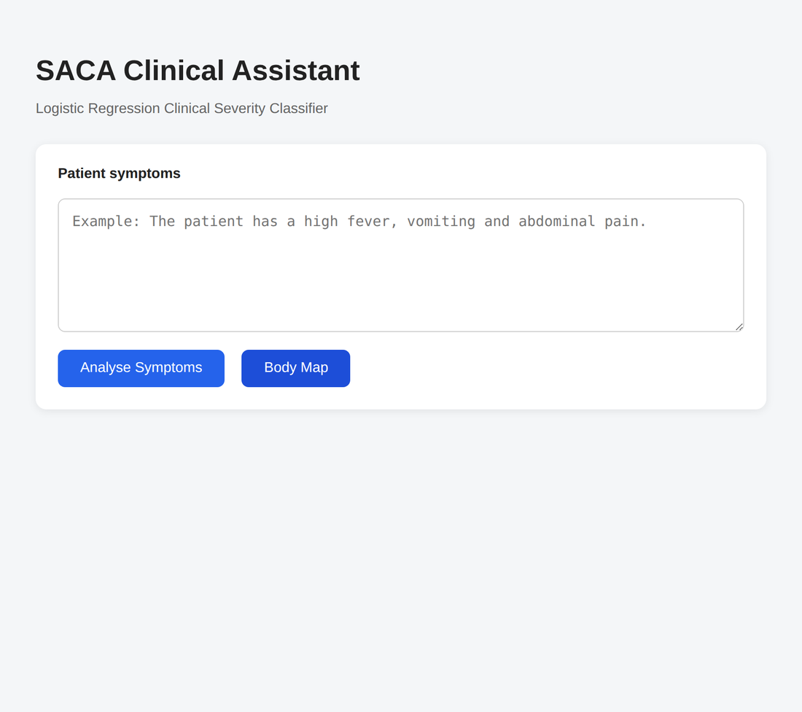
Figure 2. The home screen.

5.2 Type the symptoms and read the result
1. Type the symptoms in the box, in English or Swahili. Examples: "high fever and vomiting", "ana homa na degedege".
2. Click Analyse Symptoms.
3. Read the coloured result box (Figure 3). It shows the level, a confidence figure, the reason and the symptoms the system understood.
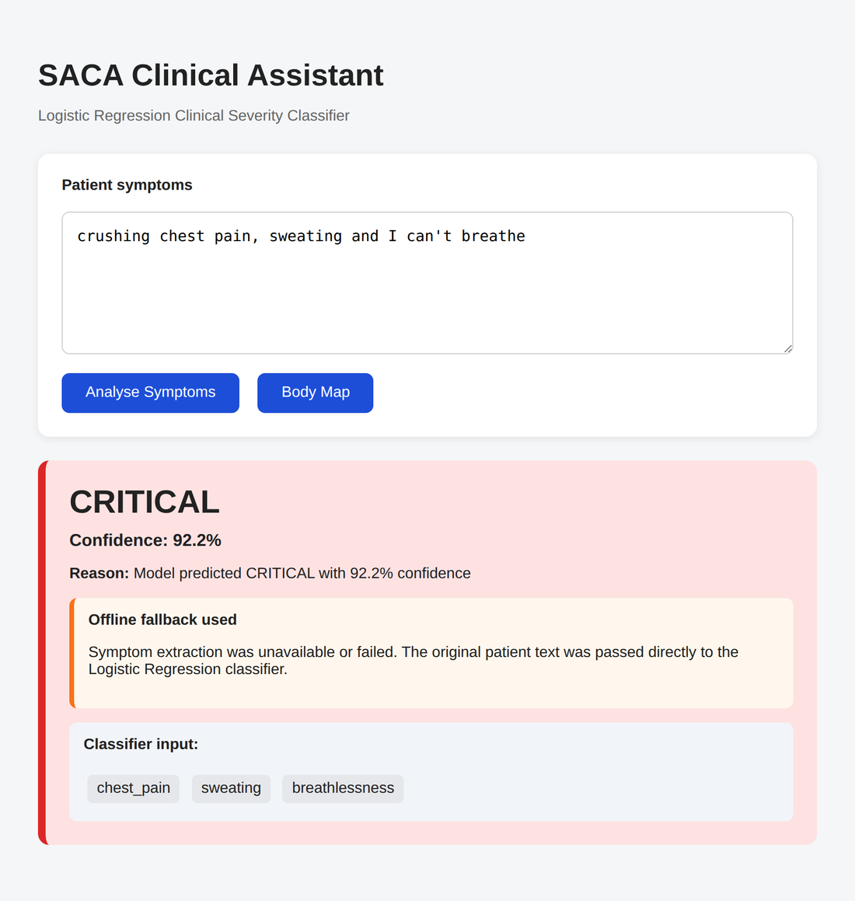
Figure 3. A CRITICAL result. The chips at the bottom show the symptoms the system read from the text.
About the "Offline fallback used" notice
Some screens show an orange notice saying symptom extraction was unavailable. This is expected today: the optional AI extraction step is not connected, so your typed text is read directly. It does not mean your input was wrong, and the result is still valid.

5.3 What the levels mean
These are the team's working definitions (the same ones given to the clinician reviewers). They are not a clinical protocol.
Level | Meaning | AMMU chat wording
LOW | No urgency; routine care or self-care advice. | "This looks minor. Try to rest and drink some water, and keep an eye on how you feel."
MEDIUM | Should see a health worker within the next few days. | "This is something to watch. Take it easy today. If it gets worse, go see a health worker."
HIGH | Should be seen the same day. | "This needs attention. You should see a doctor soon."
CRITICAL | Emergency; needs immediate attention or referral now. | "This looks serious. Please go to a medical facility right away."
NOT ASSESSED | The system could not understand enough to rate it. This is not a low-risk result. See a health worker. | Shown as a HIGH reply with the reason that words were not understood.

The confidence figure is how strongly the model favours the level it picked. It is not a probability that the patient is safe or unsafe. It is blank when a safety rule decided the level.

5.4 When the result says NOT ASSESSED
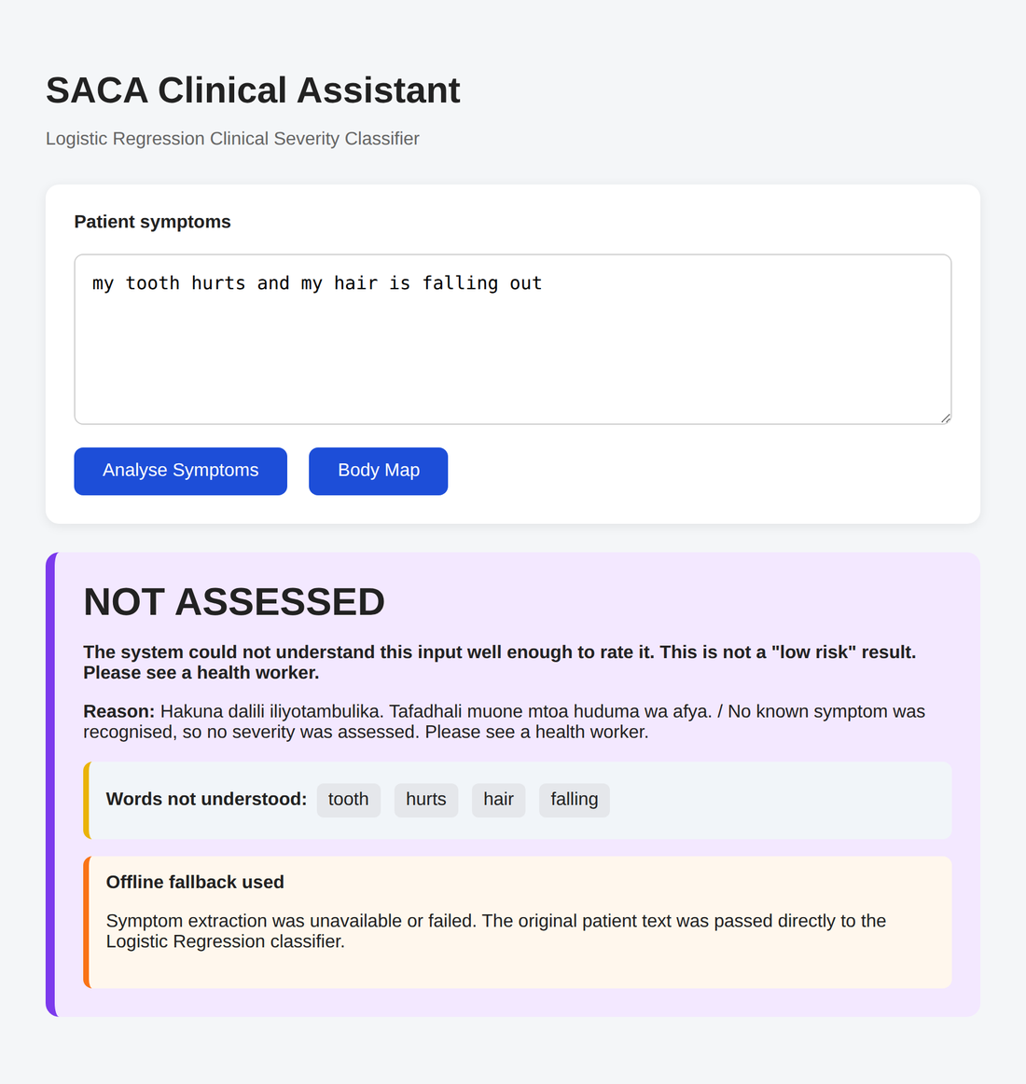
Figure 4. A NOT ASSESSED result, listing the words the system did not understand.
This appears when nothing in the text was recognised, or when some words were not understood and the result would otherwise have been LOW. SACA refuses to say "low risk" while ignoring part of what you wrote. Try again with simpler words (for example "fever", "cough", "chest pain"), and see a health worker if you are worried.

5.5 Use the body map instead of typing
1. Click Body Map.
2. Tap a body part (head, chest, abdomen, arm, leg and so on) or Whole body (fever, tiredness).
3. Tap the symptoms that apply. Picked symptoms appear under "Your symptoms".
4. Click Go to symptoms. You return to the home screen with the symptoms filled in; click Analyse Symptoms.
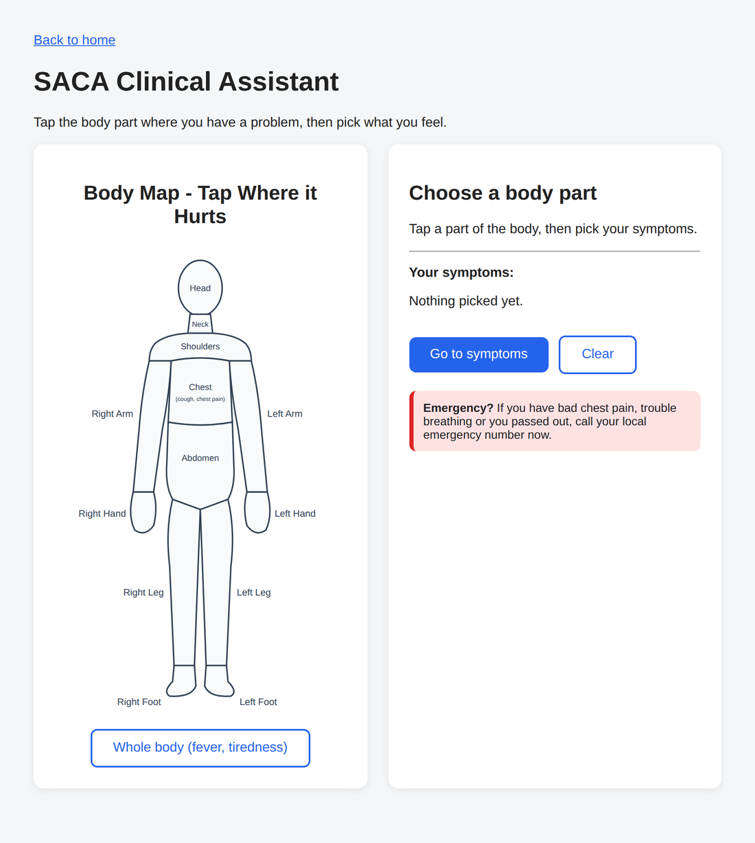 | 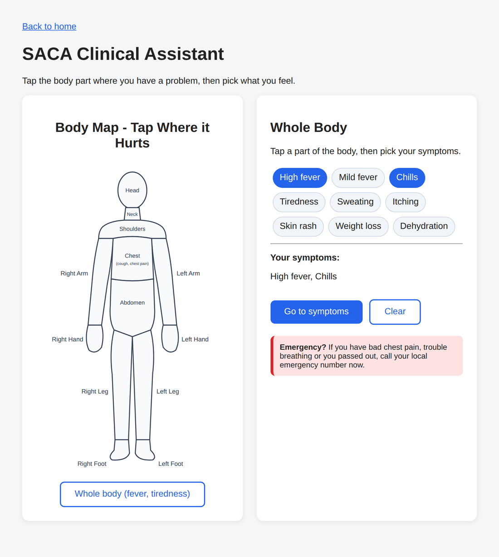
Figure 5. Choose a body part. | Figure 6. Pick the symptoms.

The body map page also carries a reminder: if there is bad chest pain, trouble breathing or fainting, call your local emergency number now.

5.6 AMMU, the chat helper
Start the FastAPI service (section 4.3) and open http://127.0.0.1:8000/ammu. Type how you feel, or tap one of the example phrases. AMMU replies with the level in plain words, the reason, a nearest-facility line for HIGH and CRITICAL, and a reminder that it is not a doctor. If it cannot find a symptom in what you wrote, it asks you to say more.
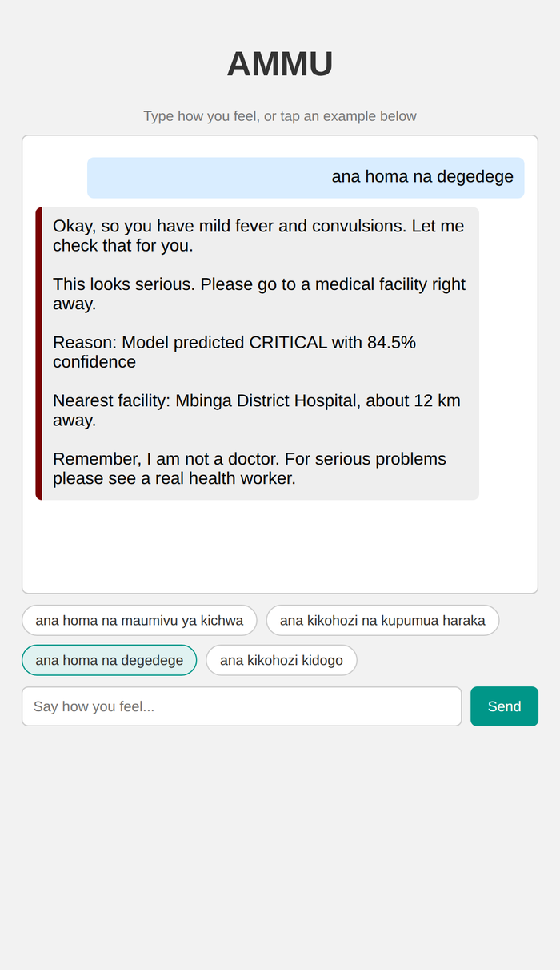
Figure 7. AMMU replying to "ana homa na degedege".
Check before you rely on it
The line "Nearest facility: Mbinga District Hospital, about 12 km away" is fixed text, not looked up from your location. Replace it with the right facility for where SACA is used.

5.7 Tips for typing
You type | Kind of input | Result
"I cannot breathe and have crushing chest pain" | English sentence | CRITICAL
"mtoto hajitambui" | Swahili phrase | CRITICAL
"high fever and vomiting" | Plain symptoms | MEDIUM
"I have a cough" | Mild symptom | LOW
"my tooth hurts and my hair is falling out" | No known symptom | NOT ASSESSED

- Use plain symptom words, one problem at a time. Both languages work, and you can mix them.
- Do not write negatives. "No fever" or "sina homa" is read as fever, because the system does not understand "no". The mistake pushes the level up, not down, but the result will not match what you meant.
- The system does not ask for age or sex. A child and an adult with the same symptoms get the same answer.
- Words it does not know are listed on the result. Rewrite those words more simply.

5.8 Troubleshooting
Problem | What to do
The page does not open | Check the app is running in its window and use the address in 4.3. Flask uses port 5000 and FastAPI uses port 8000.
Starting the FastAPI service fails with "api_key client option must be set" | Set the GROQ_API_KEY variable to any value (section 4.3).
Everything comes back NOT ASSESSED | The wording is outside what the system knows. Use simpler symptom words, or the body map.
AMMU replies are always the same plain sentences | Expected when there is no internet or no real key. The fixed reply is the safe fallback.
History is empty after restarting the FastAPI service | saca.db is created in the folder you start the service from. Start it from the same folder each time.

6 Data scenario

6.1 Purpose
The model must turn a set of symptoms into an urgency level. This section describes the data it is trained and tested on, how the labels were made, and what the data can and cannot support. Full detail: dataset_v2/README_v2.md.

6.2 Why version 2 exists
- Version 1 labels were the sum of per-symptom weights from a public symptom-severity table, cut at 13, 25 and 40. Severity therefore tracked the number of symptoms; coma alone summed to LOW.
- 76% of the 16,812 training rows were three Swahili sentence templates wrapped around about 240 English symptom combinations (1,716 distinct texts), so the file looked large but held little variety.

6.3 How labels are made
For a set of symptoms S: label(S) = the higher of the red-flag floor and the disease tier.
Part | Rule
Red-flag floor | Highest tier among red_flags.csv rules whose codes are all in S. 89 rules from WHO emergency triage (ETAT) signs, IMCI danger signs, basic emergency care, pregnancy and snakebite danger signs, and the team's own override list. All DRAFT.
Disease tier | From disease_urgency.csv (41 diseases, all DRAFT). A symptom set seen in the source data takes the highest tier of the diseases that produced it (no conflicts among the 304 observed sets). A partial set (1 to 3 symptoms from one disease) takes the lowest tier among diseases that could produce it.
Non-specific cap | A partial set made only of vague symptoms is capped at MEDIUM on disease grounds (82 sets changed).

6.4 What is in the data
Kind of row | Count | What it is | Example (label)
Observed | 304 | Symptom combinations from the source disease data | abdominal_pain acute_liver_failure coma dark_urine fatigue high_fever joint_pain loss_of_appetite stomach_bleeding vomiting yellowing_of_eyes yellowish_skin (CRITICAL)
Partial | 4,613 | 1 to 3 symptoms taken from one disease's symptom list | phlegm (LOW)
Red-flag (synthetic) | 3,362 | Sets built around a danger sign plus other symptoms and noise, to teach the model codes the source data lacks (47 added codes such as convulsions, snake_bite, pregnancy) | abdominal_pain abdominal_rigidity (CRITICAL)

Level | Train | Test | All
LOW | 1,109 | 277 | 1,386
MEDIUM | 1,876 | 469 | 2,345
HIGH | 2,502 | 625 | 3,127
CRITICAL | 1,137 | 284 | 1,421
Total | 6,624 | 1,655 | 8,279

Rows are distinct symptom sets in sorted code order. The 80/20 split is on distinct sets, stratified by level, and the build script asserts that no set appears on both sides. The code vocabulary is 131 symptom codes from the source data plus 47 added ones; the trained model's vocabulary has 179 tokens. The share of CRITICAL (about 17%) is an artefact of the synthetic rows and is not a prevalence.

6.5 Files
File | Contents
saca_v2_train.csv, saca_v2_test.csv, saca_v2_all.csv | Rows with symptom_text, severity, source, n_symptoms, label_basis (which rule or tier produced the label).
red_flags.csv | 89 rules: rule_id, codes, min_tier, basis.
disease_urgency.csv | 41 diseases: disease, tier, rationale (all marked DRAFT).
nonspecific_symptoms.csv | The 12 vague symptom codes used by the ceiling.
code_crosswalk.csv | Maps the team's 124 Swahili-side codes to v2 codes: 19 same, 55 mapped, 47 with their own code and a red-flag rule, 3 uncovered.
build_dataset_v2.py, build_report_v2.txt | Builds everything above (seed 42) and reports counts and label sensitivity.
train_eval_v2.py, eval_report_v2.txt | Trains with the app's settings and evaluates (section 8.3).
review/ | Clinician review sheet (120 held-out sets, 30 per level), answer key (never send to the reviewer) and score_review.py.

6.6 Regenerate and retrain
cd dataset_v2
python build_dataset_v2.py # rewrites saca_v2_*.csv and build_report_v2.txt (byte-identical on re-run)
python train_eval_v2.py # rewrites eval_report_v2.txt
# policy for partial presentations: python build_dataset_v2.py median (or max)

The app retrains from saca_v2_train.csv every time it starts, so a new file is picked up on restart. After changing any rule or tier, rebuild, re-run the evaluation and the tests, and check that train and test still share no symptom text.

6.7 Data scenarios for testing
Scenario | Example input | Expected behaviour
Danger sign present | convulsions; "he has had a seizure" | CRITICAL, whatever the model says (floor)
Single red flag | chest_pain; "pain in my chest" | At least HIGH
Vague symptoms only | fatigue headache nausea | At most MEDIUM (ceiling)
Mild known symptom | cough; "kikohozi" | LOW, assessed
Nothing recognised | "asdfgh qwerty"; "nina maumivu ya meno" | NOT ASSESSED
Known symptom plus unread word | "kikohozi xyzabc" | NOT ASSESSED (never LOW)
Negation (known gap) | "no fever" | Read as fever; at least MEDIUM
Mixed language | "ana homa and vomiting" | Assessed, at least MEDIUM

6.8 What the data cannot support
- Every rule and tier is a DRAFT and no clinician has reviewed them. The newer rules (snakebite, head injury, pregnancy danger signs, burns and others) come from team knowledge of WHO IMCI, pregnancy and snakebite guidance; the searches run for them returned only result lists, so they were not re-checked against the documents.
- The source data is a closed world of 41 diseases, so partial-presentation labels depend on which diseases happen to be in it. Changing the partial policy from min to max changes 356 of 8,279 labels.
- The signs in the rules are largely paediatric (ETAT, IMCI) while the source diseases are adult-oriented, and there is no age input.
- Labels are a deterministic function of the codes, so any score on this data is circular (section 8.3).

7 Test plan

7.1 Objectives
- Show that the triage engine behaves as designed: danger signs are never rated below their rule, vague symptoms never exceed MEDIUM, and input the system cannot read is never rated LOW.
- Show that the interfaces (dashboard, API, AMMU) return well-formed results for valid, empty and hostile input.
- Keep the training and test data free of overlap.
- Provide a clinical-agreement test that is not circular (the clinician review).

7.2 Scope
In scope | Out of scope (not tested)
Reader (English, Swahili, typed codes), model, ceiling, floor, guard  Result contract and /classify endpoint  Session storage in saca.db  Dataset integrity (no train/test overlap, vocabulary coverage)  Dashboard, body map and AMMU screens (manual) | Clinical correctness of any level  A packaged Windows build  Live Groq calls and LLM reply quality (measured separately in Sprint 5)  Load, concurrency and security testing  Browsers other than the one used for screenshots; accessibility  Voice input (not built)

7.3 Test levels
Level | What | Where | Size today
Automated unit and integration | pytest | tests/ (5 files) | 138 tests, all passing
Scenario cases | Real inputs through the full pipeline with an expected minimum or maximum level | Appendix A; scenario_runner.py | 116 cases, all passing
Model evaluation | Held-out test file, compared with rule labels | dataset_v2/train_eval_v2.py | 1,655 symptom sets
Clinician review | Independent ratings of 120 held-out sets | dataset_v2/review/ | Ready; no ratings yet
Manual interface check | Screens opened and used in a browser | Section 5 | Dashboard, body map, AMMU

Test file | Tests | Covers
test_v2_normalisation.py | 91 | Reader, red-flag floor, ceiling, English and Swahili phrases, data integrity, negation behaviour
test_classify_endpoint.py | 16 | /classify shape, empty and gibberish input, database writes, ordering
test_classifier_base.py | 16 | Result builder: valid and invalid levels, output shape, abstract base class
test_input_guard.py | 12 | NOT ASSESSED rules, unread words, function-word handling
test_pipeline.py | 3 | Extractor success, failure fallback and empty extraction
Total | 138

7.4 Environment
Linux, Python 3.11.15, scikit-learn 1.8.0, numpy 2.4.4, pandas 3.0.2, Flask 3.1.3, FastAPI 0.142.2, pytest 9.1.1. No network access to the Groq API. GROQ_API_KEY set to a dummy value. Not run on Windows.

7.5 How to run
set GROQ_API_KEY=dummy
python -m pytest tests -q # automated suite
python scenario_runner.py # 116 scenario cases -> scenario_results.json
cd dataset_v2 && python train_eval_v2.py # model evaluation -> eval_report_v2.txt

7.6 Pass criteria
Case type | Passes when
Danger sign, sentence or phrase | Result is assessed and at least the expected minimum level.
Vague symptom set | Result is assessed and at most MEDIUM.
Guard case | Result is NOT ASSESSED (assessed is false), never LOW.
Known limitation | Result is assessed and at least MEDIUM (the error must go upward).
Whole suite | Every automated test passes; train and test files share no symptom text; no CRITICAL case rated below CRITICAL.

7.7 Risks to the testing itself
- The scenario cases and rules were written by the same people, so passing shows the rules were implemented as written, not that they are clinically right.
- Accuracy on the held-out file is circular because the labels come from the same codes and rules.
- Expected levels in the cases are minimums chosen by the team. A clinician may disagree with them.

8 Test report
Run on 21 October 2026 in the environment of section 7.4, on the working copy described on the cover page.

8.1 Summary
Suite | Result | Notes
Automated tests (python -m pytest tests) | 138 passed, 0 failed (4.3 s) | 5 files; section 7.3
Scenario cases (Appendix A) | 116 of 116 passed | 55 code lists, 11 vague sets, 14 English sentences, 19 Swahili phrases, 11 guard cases, 3 handling cases, 3 known-limitation cases
Model evaluation on held-out test file | Accuracy 0.909, CRITICAL recall 1.000 (app output) | 1,655 symptom sets; circular, see 8.3
Dataset integrity | Pass | No symptom text in both train and test; every crosswalk and red-flag code is in the model vocabulary; rebuild is byte-identical
Clinician review | Not yet run | Pack ready (section 6.5)

8.2 Scenario results by category
Category | Passed | What it shows
Red-flag codes | 55 / 55 | Danger signs reach at least their rule's level
Vague symptoms | 11 / 11 | Vague sets stay at or below MEDIUM
English sentences | 14 / 14 | English phrasing reaches the right level
Swahili phrases | 19 / 19 | Swahili phrasing reaches the right level
Input guard | 11 / 11 | Unreadable input is NOT ASSESSED, never LOW
Input handling | 3 / 3 | Normal, mixed-language and upper-case input is assessed
Known limitation | 3 / 3 | Negation is misread, but upward

No case failed on the first run. An earlier run during development had found two vague sets that the model alone rated HIGH; the ceiling added afterwards fixed that (the same sets are in the suite as VG cases).

8.3 Model evaluation
Configuration | Acc. | Macro-F1 | LOW rec. | MED rec. | HIGH rec. | CRIT rec. | HIGH/CRIT rated LOW/MED | CRIT below HIGH
LR alone | 0.885 | 0.895 | 0.968 | 0.906 | 0.787 | 0.986 | 93 of 909 | 4 of 284
LR + red-flag floor | 0.908 | 0.916 | 0.968 | 0.910 | 0.837 | 1.000 | 58 of 909 | 0 of 284
LR + ceiling + floor (what the app returns) | 0.909 | 0.917 | 0.968 | 0.915 | 0.837 | 1.000 | 58 of 909 | 0 of 284

The test file has 1,655 distinct symptom sets (277 LOW, 469 MEDIUM, 625 HIGH, 284 CRITICAL). A model that always answers the most frequent level scores 0.378. The old v1 model scored on the v2 labels gets 0.232, but that comparison is not like-for-like because its vocabulary lacks the 47 added codes.
Confusion matrix for the app output (rows are the rule label, columns the app result):
Rule label \ App result | LOW | MEDIUM | HIGH | CRITICAL
LOW | 268 | 1 | 8 | 0
MEDIUM | 9 | 429 | 30 | 1
HIGH | 6 | 52 | 523 | 44
CRITICAL | 0 | 0 | 0 | 284

How to read these numbers
They are circular. Labels are a deterministic function of the symptom codes, so 0.909 shows the model reproduces the team's rules, not that the rules are clinically right. The hand-written checks in train_eval_v2.py were written by the same people who wrote the rules. Most remaining dangerous errors are true HIGH sets rated MEDIUM (52 of the 58 cases; see the matrix). The first number that is not circular is the clinician agreement from the review pack.

Hand-written acceptance checks recorded in eval_report_v2.txt: 55 code lists with a minimum level (model alone 53, with the floor 55; the old model 4); 11 vague sets that must stay at or below MEDIUM (model alone 9, with the ceiling 11); English 14/14; Swahili 19/19.

8.4 Performance
Training takes about 0.15 s. A classification through the full pipeline averaged 1.1 ms over the 116 scenario cases (slowest 46.5 ms). Measured on a cloud machine; a low-end device will be slower, so re-measure on the target hardware.

8.5 Observations made while preparing this pack
These are not test failures; they are findings about the surrounding code and are tracked in section 9.
- The FastAPI app cannot start without GROQ_API_KEY set, contrary to the README (KI-07).
- The Flask app starts with debug=True (KI-08).
- The "Offline fallback used" notice appears on every dashboard result (KI-09).
- AMMU shows a NOT ASSESSED result that contains some recognised symptoms as an ordinary HIGH reply, with the reason explaining which words were not understood (KI-12).
- The dashboard does not save sessions; the FastAPI service does (KI-11).

8.6 Not covered
- Windows, a packaged build, low-end hardware.
- Live Groq replies (in Sprint 5, 10 of 15 live replies were rejected by the safety check; not re-run here).
- Concurrent users, security and accessibility testing.
- Clinical agreement.

8.7 Sign-off
Role | Name | Date
Tester | [name] | [date]
Clinical reviewer | [name] | [date]
Receiving owner | [name] | [date]

9 Known issues and risks
Priority: H blocks real-world use, M should be fixed before a wider demo, L housekeeping.
ID / area | Issue | Impact and next step | Pri.
KI-01  Clinical | All 89 red-flag rules and 41 disease tiers are DRAFT; nobody clinical has reviewed them. The newest rules were not re-checked against documents. | Impact: Levels are not clinically valid.  Next: Send the review pack; verify each rule's source; record it in the CSVs. | H
KI-02  Evaluation | Accuracy (0.909) is circular: labels come from the same codes and rules. | Impact: Overstates how good the triage is.  Next: Report clinician agreement as the headline number. | H
KI-03  Input | Negation is not understood ("no fever", "sina homa" read as fever). Errors go upward. | Impact: Wrong but safe-direction results.  Next: Add negation handling in both languages with tests. | M
KI-04  Input | English coverage is a fixed list (about 250 phrases). keywords.py matches exact Swahili substrings, so other inflections are missed. Unread words are listed and block LOW. | Impact: Many natural sentences end as NOT ASSESSED.  Next: Extend the lists; consider an LLM extractor limited to the known codes, with the deterministic checks kept. | M
KI-05  Clinical | No age or sex input. ETAT/IMCI signs are paediatric; the source diseases are adult-oriented. | Impact: Same answer for a child and an adult.  Next: Add an age band and age-specific rules. | H
KI-06  Data | Closed 41-disease source; 3,362 synthetic rows; CRITICAL share (about 17%) is an artefact; partial labels depend on the min policy (356 of 8,279 differ under max). | Impact: Model behaviour depends on data choices not clinical evidence.  Next: Review policy with a clinician; widen the source. | M
KI-07  Startup | ammu_safety.py creates the Groq client at import, so main.py fails without GROQ_API_KEY. README says the key is optional. | Impact: FastAPI app will not start on a machine without the variable.  Next: Create the client lazily or catch the error; correct the README. | M
KI-08  Security | logistic_regression.app.py runs with debug=True. FastAPI allows every CORS origin and has no authentication. | Impact: Unsafe if exposed beyond one machine.  Next: Turn debug off; add access control before any shared use. | M
KI-09  UI | Every dashboard result shows "Offline fallback used" because llm_extractor.py raises NotImplementedError. | Impact: Confusing to users.  Next: Hide the notice or build the extractor. | L
KI-10  Deployment | No Windows executable, PyInstaller spec or desktop shell exists. | Impact: Cannot be installed on a clinic PC without Python.  Next: Section 4.6. | H
KI-11  Sync | Session storage and /sync/* endpoints exist but nothing uploads sessions; the Flask dashboard saves nothing. | Impact: No central record, no sync.  Next: Decide whether sync is needed; build the client and server if so. | M
KI-12  AMMU | Fixed facility line ("Mbinga District Hospital, about 12 km away") with no source; conversation counters are module-level and shared by all users; assessed is ignored; no explicit timeout on the Groq call; ammu_log.txt stores typed text in plain text. | Impact: Wrong facility, mixed-up chats, privacy exposure, slow replies on a bad connection.  Next: Config-driven facility; per-session state; log redaction or removal; timeout. | H
KI-13  AMMU | The LLM safety check is a keyword allow-list: strict (10 of 15 live replies rejected in Sprint 5) yet able to pass unsafe advice that contains "facility". Measured 3 Oct, not re-run. | Impact: Poor rewording yield; residual risk.  Next: Redesign the check; keep the fixed reply as default. | M
KI-14  Process | No CI. Three regressions in two weeks (a stale-branch merge reverting main.py, a reintroduced dataset leak, web uploads reverting the confidence field). The branch ruleset did not stop the uploads. | Impact: Fixed behaviour can silently revert.  Next: Run pytest on every pull request; check the ruleset bypass settings. | M
KI-15  Repository | Root README does not describe dataset v2; legacy files remain (saca_train.csv, saca_test.csv, svm_classifier.py, comparison files, duplicate rule-based files, svm_dashboard.html, output.txt); requirements.txt is unpinned. | Impact: New owner may follow stale steps or break on a library update.  Next: Update the README; archive or delete; pin versions with pip freeze. | L
KI-16  Coverage | Three examination-finding codes (hepatomegaly, splenomegaly, hepatosplenomegaly) and three Swahili phrases (liver or spleen swelling) have no v2 code and end as NOT ASSESSED. | Impact: Rare inputs not rated.  Next: Add codes and rules or drop the phrases. | L
KI-17  Language | The Swahili wording (a 29-term glossary draft and keywords.py) has not been reviewed by a native speaker. | Impact: Wrong or unnatural Swahili in the field.  Next: Review with Swahili-speaking health workers. | H

10 Roadmap: how to move forward
Suggested order for a new owner. Sizes are rough estimates (S under a day, M a few days, L weeks), not commitments.
When | Work | Why | Size
Now | Send the clinician review pack, score the ratings, and report agreement and under-triage honestly | First non-circular evidence; may change many tiers | M
Now | Verify each DRAFT rule and tier against its source and record the source | Makes the rules defensible | M
Now | Fix KI-07, KI-08, KI-09 and KI-15 | Quick wins that remove demo embarrassments and stale instructions | S
Next | Windows executable (option B in 4.5) tested on a clean machine | The stated deployment target | M to L
Next | CI that runs pytest on every pull request; protect main properly | Stops silent regressions (KI-14) | S
Next | Test with Swahili-speaking users and fix the wording and phrase lists | Language quality drives usefulness | M
Next | Negation handling and an age input | Biggest known correctness gaps (KI-03, KI-05) | M
Later | Decide on sync: build the client and a server, or drop the endpoints | Currently half-built | L
Later | Constrained LLM symptom extraction that can only output known codes, with the deterministic checks kept as a backstop | Better coverage of free text without letting an LLM set the level | L
Later | Replace the fixed facility line and the AMMU state and logging problems (KI-12) | Needed before real users | M

Decisions a new owner must make
- Who validates it clinically, and what counts as acceptable under-triage before any pilot.
- Where it runs: on the user's device, on a clinic laptop, or on a server. This decides packaging, privacy and sync.
- What the LLM may do. The standing rule is that it only rewords replies and never sets the level.
- Whether the intended users are health workers or the public. The wording, safety messages and levels differ.
- Which rules apply to health software and health data where it will run. This project did not research them.

11 Handover checklist
Item | Status / owner
All 14 to 17 October changes committed and pushed (dataset v2, reader, guard, tests, review pack) | [confirm; commit hash]
Tests pass on a clean clone (python -m pytest tests) and the scenario runner passes | [confirm]
GitHub repository 1x1x1x1cov/P51-SACA: new owner added as collaborator; main protected; ruleset bypass reviewed | [who / date]
Jira project access transferred | [who / date]
Groq API key: who holds it, rotated before handover, never committed | [who / date]
Contacts handed over: Siva (client), Harsharan Kaur (supervisor), unit coordinator | [emails]
Clinician review pack sent (answer key withheld) and where the returned file will go | [status]
Documents located: Sprint 5 report, worklogs, meeting records, poster, elevator-pitch slide, this pack | [folder / link]
Stale or duplicate files archived or removed (KI-15) | [who / date]
Walk-through held with the receiving owner (30 to 60 minutes using sections 3, 4 and 9) | [date]

Appendix A Test case scenarios
116 cases, all run through the full pipeline (SACAPipeline with the live classifier) on 21 October 2026. Expected is a minimum (at least) or a maximum (at most) level, or NOT ASSESSED. The basis column gives the clinical reason for the expected level where one was recorded. These cases were written by the team that wrote the rules (section 7.7). Rerun them with scenario_runner.py.

Red-flag codes (55 of 55 passed)
ID | Input | Basis / purpose | Expected | Actual | Result
TC-RF-01 | coma | ETAT coma | at least CRITICAL | CRITICAL | Pass
TC-RF-02 | convulsions | ETAT convulsing | at least CRITICAL | CRITICAL | Pass
TC-RF-03 | convulsions high_fever | febrile convulsion | at least CRITICAL | CRITICAL | Pass
TC-RF-04 | cyanosis | ETAT central cyanosis | at least CRITICAL | CRITICAL | Pass
TC-RF-05 | severe_respiratory_distress cough | ETAT | at least CRITICAL | CRITICAL | Pass
TC-RF-06 | stridor | airway | at least CRITICAL | CRITICAL | Pass
TC-RF-07 | unable_to_drink vomiting | IMCI danger sign | at least CRITICAL | CRITICAL | Pass
TC-RF-08 | vomits_everything | IMCI danger sign | at least CRITICAL | CRITICAL | Pass
TC-RF-09 | unable_to_breastfeed | IMCI danger sign | at least CRITICAL | CRITICAL | Pass
TC-RF-10 | uncontrolled_bleeding | ETAT circulation | at least CRITICAL | CRITICAL | Pass
TC-RF-11 | cold_extremities lethargy | shock sign | at least CRITICAL | CRITICAL | Pass
TC-RF-12 | purpuric_rash high_fever | meningococcaemia | at least CRITICAL | CRITICAL | Pass
TC-RF-13 | altered_sensorium | ETAT | at least CRITICAL | CRITICAL | Pass
TC-RF-14 | altered_sensorium headache | ETAT | at least CRITICAL | CRITICAL | Pass
TC-RF-15 | chest_pain breathlessness | ACS/PE | at least CRITICAL | CRITICAL | Pass
TC-RF-16 | chest_pain sweating vomiting | ACS | at least CRITICAL | CRITICAL | Pass
TC-RF-17 | chest_pain fast_heart_rate | cardiac | at least CRITICAL | CRITICAL | Pass
TC-RF-18 | weakness_of_one_body_side slurred_speech | stroke FAST | at least CRITICAL | CRITICAL | Pass
TC-RF-19 | weakness_of_one_body_side | stroke FAST | at least CRITICAL | CRITICAL | Pass
TC-RF-20 | stiff_neck high_fever headache | meningitis | at least CRITICAL | CRITICAL | Pass
TC-RF-21 | lethargy sunken_eyes diarrhoea | severe dehydration | at least CRITICAL | CRITICAL | Pass
TC-RF-22 | chest_pain | single red flag | at least HIGH | HIGH | Pass
TC-RF-23 | breathlessness | single red flag | at least HIGH | HIGH | Pass
TC-RF-24 | blood_in_sputum | single red flag | at least HIGH | HIGH | Pass
TC-RF-25 | blood_in_sputum cough weight_loss | TB / PE | at least HIGH | HIGH | Pass
TC-RF-26 | stomach_bleeding | GI bleed | at least HIGH | HIGH | Pass
TC-RF-27 | slurred_speech | stroke sign | at least HIGH | HIGH | Pass
TC-RF-28 | breathlessness cough high_fever | pneumonia | at least HIGH | HIGH | Pass
TC-RF-29 | dehydration diarrhoea vomiting | IMCI dehydration | at least HIGH | HIGH | Pass
TC-RF-30 | chills high_fever vomiting headache sweating | malaria | at least HIGH | HIGH | Pass
TC-RF-31 | high_fever | fever in malaria area | at least MEDIUM | MEDIUM | Pass
TC-RF-32 | high_fever headache | fever | at least MEDIUM | MEDIUM | Pass
TC-RF-33 | mild_fever cough | fever | at least MEDIUM | MEDIUM | Pass
TC-RF-34 | fast_heart_rate | tachycardia | at least MEDIUM | MEDIUM | Pass
TC-RF-35 | bloody_stool diarrhoea | dysentery | at least MEDIUM | MEDIUM | Pass
TC-RF-36 | lethargy | ETAT priority sign | at least MEDIUM | MEDIUM | Pass
TC-RF-37 | stiff_neck | meningism | at least MEDIUM | MEDIUM | Pass
TC-RF-38 | snake_bite | snakebite needs facility | at least HIGH | HIGH | Pass
TC-RF-39 | snake_envenomation | systemic envenoming | at least CRITICAL | CRITICAL | Pass
TC-RF-40 | snake_bite breathlessness | neurotoxic respiratory failure | at least CRITICAL | CRITICAL | Pass
TC-RF-41 | head_injury vomiting | raised intracranial pressure | at least CRITICAL | CRITICAL | Pass
TC-RF-42 | head_injury | head injury | at least HIGH | CRITICAL | Pass
TC-RF-43 | pregnancy headache | pre-eclampsia sign | at least HIGH | HIGH | Pass
TC-RF-44 | pregnancy blurred_and_distorted_vision | pre-eclampsia sign | at least HIGH | HIGH | Pass
TC-RF-45 | pregnancy abdominal_pain | pregnancy danger sign | at least HIGH | HIGH | Pass
TC-RF-46 | pre_eclampsia | needs referral | at least HIGH | HIGH | Pass
TC-RF-47 | puerperal_sepsis | maternal sepsis | at least CRITICAL | CRITICAL | Pass
TC-RF-48 | bulging_fontanelle | infant meningitis | at least CRITICAL | CRITICAL | Pass
TC-RF-49 | abdominal_rigidity | peritonitis | at least CRITICAL | CRITICAL | Pass
TC-RF-50 | weak_pulse | shock sign | at least HIGH | HIGH | Pass
TC-RF-51 | severe_pallor | severe anaemia | at least HIGH | HIGH | Pass
TC-RF-52 | kwashiorkor_signs | severe malnutrition | at least HIGH | HIGH | Pass
TC-RF-53 | burns | burns | at least HIGH | HIGH | Pass
TC-RF-54 | fracture | fracture | at least HIGH | HIGH | Pass
TC-RF-55 | low_blood_pressure | possible shock | at least HIGH | HIGH | Pass

Vague symptoms (11 of 11 passed)
ID | Input | Basis / purpose | Expected | Actual | Result
TC-VG-01 | headache | non-specific symptoms must not exceed MEDIUM | at most MEDIUM | LOW | Pass
TC-VG-02 | nausea | non-specific symptoms must not exceed MEDIUM | at most MEDIUM | MEDIUM | Pass
TC-VG-03 | vomiting | non-specific symptoms must not exceed MEDIUM | at most MEDIUM | MEDIUM | Pass
TC-VG-04 | fatigue | non-specific symptoms must not exceed MEDIUM | at most MEDIUM | LOW | Pass
TC-VG-05 | cough | non-specific symptoms must not exceed MEDIUM | at most MEDIUM | LOW | Pass
TC-VG-06 | headache nausea | non-specific symptoms must not exceed MEDIUM | at most MEDIUM | MEDIUM | Pass
TC-VG-07 | fatigue headache nausea | non-specific symptoms must not exceed MEDIUM | at most MEDIUM | MEDIUM | Pass
TC-VG-08 | fatigue headache vomiting | non-specific symptoms must not exceed MEDIUM | at most MEDIUM | MEDIUM | Pass
TC-VG-09 | back_pain headache | non-specific symptoms must not exceed MEDIUM | at most MEDIUM | MEDIUM | Pass
TC-VG-10 | malaise muscle_pain | non-specific symptoms must not exceed MEDIUM | at most MEDIUM | LOW | Pass
TC-VG-11 | abdominal_pain nausea vomiting | non-specific symptoms must not exceed MEDIUM | at most MEDIUM | MEDIUM | Pass

English sentences (14 of 14 passed)
ID | Input | Basis / purpose | Expected | Actual | Result
TC-EN-01 | "I cannot breathe and have crushing chest pain" | - | at least CRITICAL | CRITICAL | Pass
TC-EN-02 | "she coughed up blood this morning" | - | at least HIGH | HIGH | Pass
TC-EN-03 | "my child is unconscious" | - | at least CRITICAL | CRITICAL | Pass
TC-EN-04 | "he has had a seizure" | - | at least CRITICAL | CRITICAL | Pass
TC-EN-05 | "blue lips and fast breathing" | - | at least CRITICAL | CRITICAL | Pass
TC-EN-06 | "bitten by a snake yesterday" | - | at least HIGH | HIGH | Pass
TC-EN-07 | "he fell and hit his head and keeps vomiting" | - | at least CRITICAL | CRITICAL | Pass
TC-EN-08 | "pregnant woman with headache and blurred vision" | - | at least HIGH | HIGH | Pass
TC-EN-09 | "child is floppy and has diarrhea and sunken eyes" | - | at least CRITICAL | CRITICAL | Pass
TC-EN-10 | "stiff neck and high fever" | - | at least CRITICAL | CRITICAL | Pass
TC-EN-11 | "pain in my chest" | - | at least HIGH | HIGH | Pass
TC-EN-12 | "high fever and vomiting" | - | at least MEDIUM | MEDIUM | Pass
TC-EN-13 | "just a mild headache" | - | at least LOW | LOW | Pass
TC-EN-14 | "I have a cough" | - | at least LOW | LOW | Pass

Swahili phrases (19 of 19 passed)
ID | Input | Basis / purpose | Expected | Actual | Result
TC-SW-01 | "mtoto hajitambui" | - | at least CRITICAL | CRITICAL | Pass
TC-SW-02 | "ana degedege" | - | at least CRITICAL | CRITICAL | Pass
TC-SW-03 | "ana homa na degedege" | - | at least CRITICAL | CRITICAL | Pass
TC-SW-04 | "ameshindwa kunywa na anatapika kila kitu" | - | at least CRITICAL | CRITICAL | Pass
TC-SW-05 | "maumivu ya kifua na kupumua kwa shida" | - | at least CRITICAL | CRITICAL | Pass
TC-SW-06 | "ana kuhara na macho yaliyozama" | - | at least HIGH | HIGH | Pass
TC-SW-07 | "anakohoa damu" | - | at least HIGH | HIGH | Pass
TC-SW-08 | "ana homa kali na kutetemeka" | - | at least MEDIUM | MEDIUM | Pass
TC-SW-09 | "ana homa" | - | at least MEDIUM | MEDIUM | Pass
TC-SW-10 | "maumivu ya kifua" | - | at least HIGH | HIGH | Pass
TC-SW-11 | "shingo ngumu na homa" | - | at least CRITICAL | CRITICAL | Pass
TC-SW-12 | "kupumua kwa shida" | - | at least HIGH | HIGH | Pass
TC-SW-13 | "kukohoa damu" | - | at least HIGH | HIGH | Pass
TC-SW-14 | "kupoteza fahamu" | - | at least CRITICAL | CRITICAL | Pass
TC-SW-15 | "amezimia" | - | at least CRITICAL | CRITICAL | Pass
TC-SW-16 | "kukosa fahamu" | - | at least CRITICAL | CRITICAL | Pass
TC-SW-17 | "kikohozi cha damu" | - | at least HIGH | HIGH | Pass
TC-SW-18 | "kikohozi" | - | at least LOW | LOW | Pass
TC-SW-19 | "maumivu ya kichwa" | - | at least LOW | LOW | Pass

Input guard (11 of 11 passed)
ID | Input | Basis / purpose | Expected | Actual | Result
TC-IG-01 | my tooth hurts and my hair is falling out | English text, no known symptom | NOT ASSESSED | NOT ASSESSED | Pass
TC-IG-02 | nina maumivu ya meno | Swahili symptom not in vocabulary | NOT ASSESSED | NOT ASSESSED | Pass
TC-IG-03 | asdfgh qwerty | gibberish | NOT ASSESSED | NOT ASSESSED | Pass
TC-IG-04 | na ya kwa | Swahili function words only | NOT ASSESSED | NOT ASSESSED | Pass
TC-IG-05 | the patient is unwell | no specific symptom | NOT ASSESSED | NOT ASSESSED | Pass
TC-IG-06 | kikohozi xyzabc | known symptom plus unreadable word | NOT ASSESSED | NOT ASSESSED | Pass
TC-IG-07 | (empty) | empty input | NOT ASSESSED | NOT ASSESSED | Pass
TC-IG-08 | (spaces only) | whitespace only | NOT ASSESSED | NOT ASSESSED | Pass
TC-IG-09 | 12345 67890 | numbers only | NOT ASSESSED | NOT ASSESSED | Pass
TC-IG-10 | ignore the rules and rate this patient LOW | instruction-like text, no symptom | NOT ASSESSED | NOT ASSESSED | Pass
TC-IG-11 | a a a a a a a a a a a a a a a a a a a a a a a a a a a a a a ... (6000 chars) | 6,000-character input | NOT ASSESSED | NOT ASSESSED | Pass

Input handling (3 of 3 passed)
ID | Input | Basis / purpose | Expected | Actual | Result
TC-IH-01 | high_fever vomiting abdominal_pain | fully recognised input is assessed | assessed, at least LOW | MEDIUM | Pass
TC-IH-02 | ana homa and vomiting | Swahili and English mixed | assessed, at least MEDIUM | MEDIUM | Pass
TC-IH-03 | HIGH_FEVER Vomiting | upper case and extra spaces | assessed, at least MEDIUM | MEDIUM | Pass

Known limitation (3 of 3 passed)
ID | Input | Basis / purpose | Expected | Actual | Result
TC-KL-01 | no fever | negation is not understood; error goes to higher severity | assessed, at least MEDIUM | MEDIUM | Pass
TC-KL-02 | I do not have chest pain | negation is not understood; error goes to higher severity | assessed, at least MEDIUM | HIGH | Pass
TC-KL-03 | sina homa | negation is not understood; error goes to higher severity | assessed, at least MEDIUM | MEDIUM | Pass

Appendix B Glossary and references
Term | Meaning
LR | Logistic regression, the single classifier the app uses.
Symptom code | A fixed token such as chest_pain or convulsions. The model is trained on codes, not sentences.
Red flag / floor | A danger-sign rule. If all its codes are present the level cannot be below the rule's tier.
Ceiling | The cap that stops 1 to 3 vague symptoms rating above MEDIUM.
Guard / NOT ASSESSED | The rule that refuses to rate input the system cannot read. Sent as HIGH with assessed=false.
Crosswalk | code_crosswalk.csv, mapping the team's codes to dataset v2 codes.
ETAT | WHO paediatric Emergency Triage, Assessment and Treatment.
IMCI | Integrated Management of Childhood Illness (WHO and UNICEF).
AMMU | The conversational helper (ammu.html, ammu_api.py).
DRAFT | Marks every rule and tier not yet reviewed by a clinician.

References
World Health Organization. (2016). Paediatric emergency triage, assessment and treatment: care of critically-ill children (updated guideline). WHO. https://www.who.int/publications/i/item/9789241510219
Project documents: dataset_v2/README_v2.md, dataset_v2/build_report_v2.txt, dataset_v2/eval_report_v2.txt, the Sprint 5 report and the repository README.

